Butterworth Filters

| Order | g1 | g2 | g3 | g4 | g5 | g6 |
| --- | --- | --- | --- | --- | --- | --- |
| 3rd | L=50 nH  C=.0051 pF | L=.0063 nH  C=40 pF | L=50 nH  C=.0051 pF | R=50 |  |  |
| 4th | L=38.27 nH  C=0.0066 pF | L=0.0069 nH  C=36.956 pF | L=92.39 nH  C=.0027 pF | L=.0165 nH  C=.0027 pF | R=50 |  |
| 5th | L=30.9045 nH  C=0.0082 pF | L=0.078 nH  C=32.36 pF | L=100 nH  C=0.0025 pF | L=0.0078 nH  C=32.36 pF | L=30.9 nH  C=0.0082 pF | R=50 |

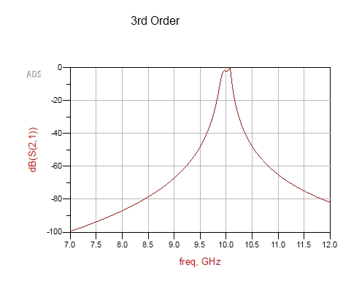

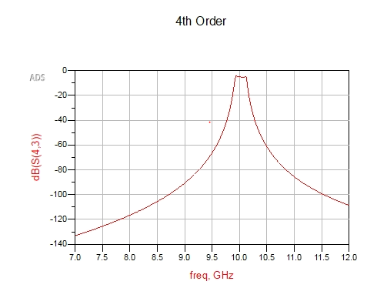

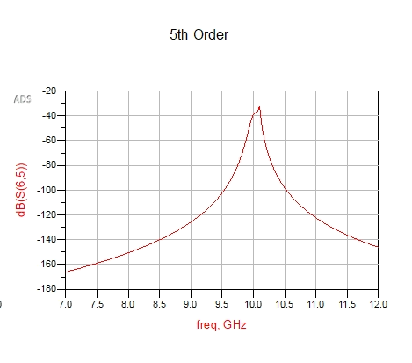

Chebychev

| Order | g1 | g2 | g3 | g4 | g5 | g6 |
| --- | --- | --- | --- | --- | --- | --- |
| 3rd | L=78.815 nH  C=0.0032 pF | L=0.0115 nH  C=21.934 pF | L=79.8150 nH  C=0.0032 pF | R=50 |  |  |
| 4th | L=83.515 nH  C=0.003 pF | L=0.0106 nH  C=23.852 pF | L=118.305 nH  C=0.021 pF | L=0.015 nH  C=16.838 pF | R=99.205 |  |
| 5th | L=85.29 nH  C=0.003 pF | L=0.0103 nH  C=24.592 pF | L=127.04 nH  C=0.002 pF | L=.0103 nH  C=24.592 pF | L=85.29 nH  C=0.003 pF | R=500 |

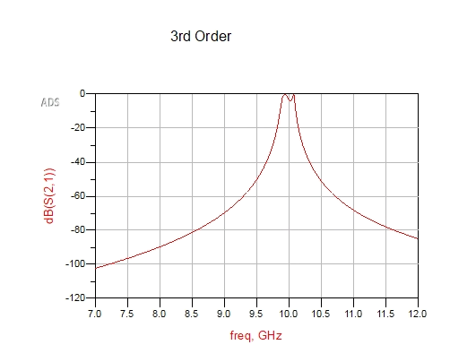

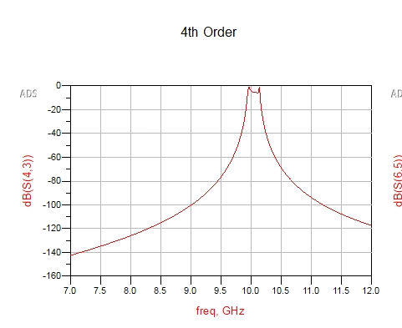

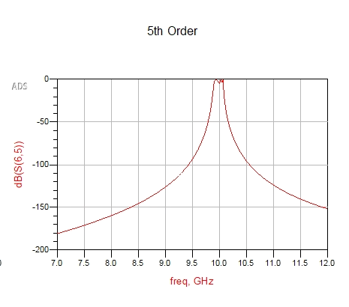

Maximally Flat (binomial I think)

| Order | g1 | g2 | g3 | g4 | g5 | g6 |
| --- | --- | --- | --- | --- | --- | --- |
| 3rd | L=62.75 nH  C=0.004 pF | L=0.0229 nH  C=11.056 pF | L=9.61 nH  C=0.0264 pF | R=50 |  |  |
| 4th | L=52.99 nH  C=0.0048 pF | L=0.0248 nH  C=10.232 pF | L=15.905 nH  C=0.0159 pF | L=0.1147 nH  C=2.208 pF | R=50 |  |
| 5th | L=46.515 nH  C=0.0054 pF | L=0.0277 nH  C=9.154 pF | L=16.56 nH  C=0.0153 pF | L=0.0606 nH  C=4.18 pF | L=3.59 nH  C=0.0706 pF | R=50 |

